**Project Design Phase-II**

**Technology Stack (Architecture & Stack)**

|  |  |
| --- | --- |
| Date | 03 October 2023 |
| Team ID | NM2023TMID05031 |
| Project Name | Solar Panel Forecasting |
| Maximum Marks | 4 Marks |

**Technical Architecture:**

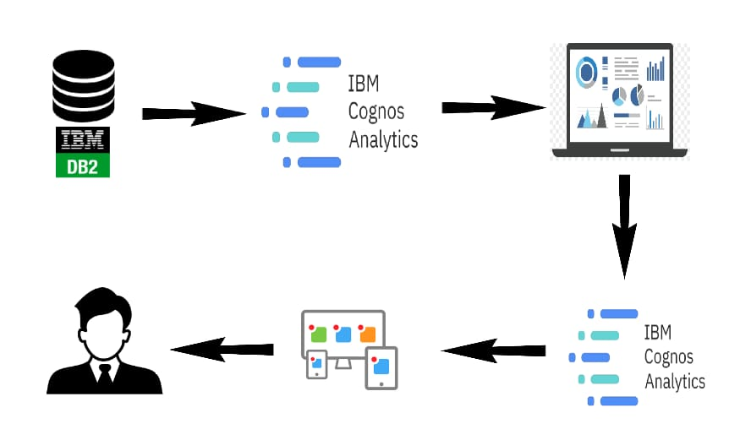

**Table-1 : Components & Technologies:**

|  |  |  |  |
| --- | --- | --- | --- |
| **S.No** | **Component** | **Description** | **Technology** |
| 1. | **Solar Panels** | Solar panels are the core components that convert sunlight into electricity. They are typically mounted on rooftops or in solar arrays | HTML, CSS, JavaScript |
| 2. | **Inverter** | The inverter is responsible for converting the direct current (DC) electricity generated by solar panels into alternating current (AC) electricity, which can be used in homes and businesses | Python |
| 3. | **Mounting System** | The mounting system securely attaches solar panels to the roof or other structures. It must ensure proper orientation and angle for maximum sun exposure | IBM Watson STT service |
| 4. | **Metering Equipment** | Metering equipment measures the amount of electricity generated by the solar panels. It may include bi-directional meters for tracking energy flow to and from the grid. | IBM Watson Assistant |
| 5. | **Monitoring Software** | Monitoring software collects data from the solar panel system, providing real-time and historical information on energy production. It may include a user-friendly interface for homeowners and installers | MySQL |
| 6. | **Maintenance Tools** | Description: These tools and equipment are used for routine maintenance and cleaning of solar panels to ensure optimal performance. | IBM DB2 |
| 7. | **Grid Connection** | Description: Grid connection components enable the integration of solar energy with the utility grid, allowing excess energy to be fed back to the grid and drawn when needed. | IBM Block Storage or Other Storage Service or Local Filesystem |
| 8. | **Information Database** | Description: An information database contains details on government incentives, tax credits, and local regulations related to solar panel installations | IBM Weather API |
| 9. | **Integration Tools** | Description: These tools help building contractors integrate solar panels or solar roof tiles seamlessly into construction projects | Aadhar API |
| 10. | **Solar Roof Tiles** | Description: Solar roof tiles are innovative solar panel technologies that can replace traditional roofing materials while generating electricity. | Object Recognition Model |
| 11. | **Educational Materials** | Description: Educational materials include articles, videos, and resources that educate homeowners, businesses, and the public about the benefits of solar energy. | Local, Kubernetes. |

**Table-2: Application Characteristics:**

|  |  |  |  |
| --- | --- | --- | --- |
| **S.No** | **Characteristics** | **Description** | **Technology** |
| 1. | **Solar Panel Estimation Platform** | This is a web-based or mobile platform that allows users to input their property details and get estimates of potential energy savings and environmental impact when installing solar panels | **Smart Grid Technology** |
| 2. | **Feasibility Study Tools** | These tools support the evaluation of large-scale solar projects, providing cost analysis, energy production projections, and environmental impact assessments. | **Website and Mobile App Development** |
| 4. | **Analysis Software** | Analysis software helps in assessing the feasibility of solar farms by simulating their performance under various conditions and analyzing the financial and environmental implications | **Solar Roof Tile Technology** |